From case conceptualization to treatment plan: using the network analysis model to create focus in treatment.

One day in the office, I am trying to understand why the story of the man in front of me doesn’t impact me emotionally. He seems very open and seems to have a clear understanding of his own psychological processes. Yet, I feel invisible to him. I can see that he is avoiding by talking about and analyzing his own processes, but what intern experience is it that he finds so hard to be present with? I can see that he is not in the present moment with me, as he is talking about his problems, although there are moments where he shows his sadness and frustration. His values seem clear, as he describes how important it is to him to be in an equal relationship, he is a caring partner and father, a sportsman, and he is passionate about his work. He has come into my office out of selfcare and I can tell he has a lot of tools to take valued actions. My ACT case conceptualizations points me into the direction of lack of present moment awareness, but how am I going to share my observations with him? Is it even relevant to him that our work together lacks togetherness for me?
During a two day workshop on Process Based Therapy in Dublin Steven Hayes and Stefan Hofmann introduced a model loosely based on the network analysis of Borsboom, Cramer and McNally, amongst others (see examples of articles on the subject below). In the model problems the client is facing, themes that he or she is struggling with, often during the course of a lifetime, are being brought together. Unlike a case conceptualization, which is somewhat static, the model is dynamic. Therapists can not only name problems, but also map their relative relevance and the way they interact with each other. It reminds me of something that was used long time ago in (C)BT in Belgium and the Netherlands, called the Holistic Theory (see Orlemans, 1987).
This came to mind as I was asking myself how I could proceed with my client and share my questions and dilemma’s with him. Together we made a Holistic Theory of his struggles. He shared with me a short history of his life, in which it became clear that not being seen in his needs and boundaries was an important theme for him. This immediately gave our work together focus. I started asking him about his needs right now, and it became apparent that he found it very difficult to answer it. He had no adequate repertoire to directly ask for what he needed. As soon as we started talking about his needs, he started talking about other people. Now I could see the experiential avoidance happening before my eyes, now I got a clear sense of what this avoidance was about.
People who are getting acquainted with ACT and start making ACT case conceptualizations often struggle with how to make those conceptualizations. There are several helpful forms, for instance the one from Learning ACT (Luoma, Hayes & Walser, 2008), or the form developed by David Gillanders (https://contextualscience.org/david_gillanders_training_page). Still, it may be difficult to use the conceptualization to make a treatment plan. Using the Holistic Theory, or the Network Model, may be a way to bridge that gap. There are several benefits. First of all, it can easily be used in collaboration with the client. Second, it is kind of a-theoretical. Kind of, because the theories the therapist has, will guide the selection of problems, themes and ways the interaction between them is hypothesized. It can be used with a ACT background, a CBT background and any other theoretical background. Once the Holistic Theory is made, we can start to relate the processes of the hexaflex to the different topics. The Holistic Theory guides what focus we choose and the Hexaflex (or any other treatment model) guides the processes by which we try to bring about change.
Example of a Holistic Theory
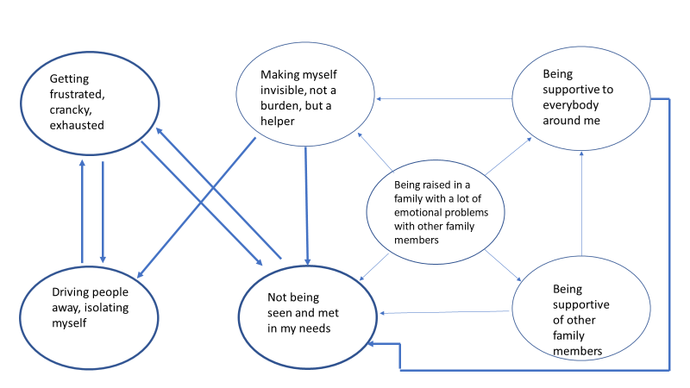

Problems or themes can be depicted as more or less important by the thickness of the lines around them. Relationships between problems or themes can be depicted as more or less important by the thickness of the lines.

For more information on Processed Based Therapy, see Hayes & Hofmann, 2018; Hayes et al., in press; Hofmann & Hayes, in press.

Literature
van Borkulo, C., Boschloo, L., Borsboom, D. et al. (2015). Association of symptom network structure with the course of depression. JAMA Psychiatry, 72, 1219-26.
Borsboom, D. (2008). Psychometric perspectives on diagnostic systems. Journal of Clinical Psychology, 64(9), 1089–1108.
Hayes, S. C. & Hofmann, S. G. (Eds.) (2018). Process-based CBT: The science and core clinical competencies of cognitive behavioral therapy. Oakland, CA: New Harbinger Publications. ISBN-13: 978-1626255968.
Hayes, S. C., Hofmann, S. G., Stanton, C. E., Carpenter, J. K., Sanford, B. T., Curtiss, J. E., & Ciarrochi, J. (in press). The role of the individual in the coming era of process-based therapy. Behaviour Research and Therapy. DOI: 10.1016/j.brat.2018.10.005
Hofmann, S. G. & Hayes, S. C. (in press). The future of intervention science: Process based therapy. Clinical Psychological Science. Doi: 10.1177/2167702618772296
Luoma J.B., Hayes S.C. & Walser R.D. (2008). Leer ACT! Vaardigheden voor therapeuten. Houten: Bohn Stafleu van Loghum. Vertaling van: Luoma J.B., Hayes S.C., & Walser R.D. (2007). Learning ACT. Oakland: New Harbinger.
McNally, R. J. (2016). Can network analysis transform psychopathology. Behaviour Research and Therapy, 86, 95–104.
Orlemans, J.W.G. (1987). Selectie van het eerste te bewerken probleem. In J.W.G. Orlemans, P. Eelen, & W.P. Haaijman, Handboek voor Gedragstherapie deel 1 (pp. A.5-1/A.5-12). Deventer: van Loghum Slaterus.

The real Network Analysis is based on statistical analysis, although even here, theory guides what is the input which is analyzed.

