What you give yourself with forgiveness: liberation from resentment or shame
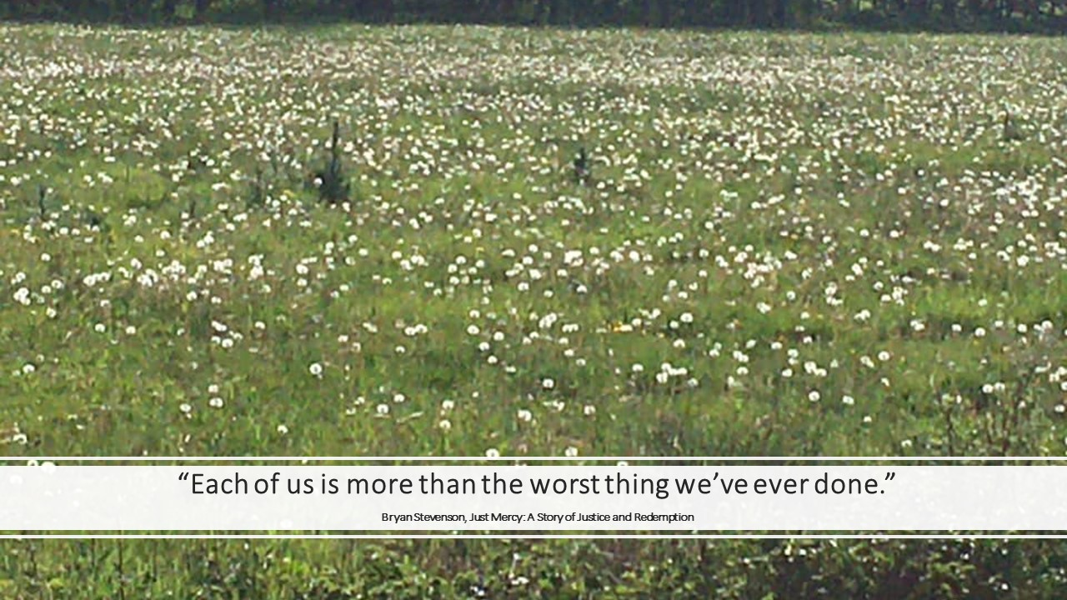
She was furious. The man who knocked her down should have given way. He had been drinking too much. He had been in fright, but she had to continue with physical problems. She couldn't do her job anymore. There were so many things she couldn't do any more. He said he was sorry. But what good was it to her? She didn't get her life back with that. It was unforgivable.
It took me a long time before I could look at myself in the mirror again, because of the mistakes I made in my life. Life went on, of course. But there was a wound deep within me. I blamed myself. And I blamed others for not stopping me or having pushed me. I accused others, but that didn't help. It made me feel more alone and misunderstood. I was ashamed and hardly dared taking about my big mistakes. I could no longer open up to others. Which prevented me from repairing the relationships that had suffered from my mistakes. My mistakes seemed unforgivable.
When others make mistakes that greatly affect our lives, we can hold a grudge. It is not called "hold" for nothing, because it is a feeling that we carry close. And of course there are mistakes, which are very serious. What we really suffer from, daily. That should not have happened, and yet happened.
And when we make mistakes ourselves, causing harm to others which doesn’t not fit the person we want to be, deep shame can become part of our lives. As if we no longer deserve that others love us, want to be associated to us. And it may be that the damage we inflicted is great. That others will be shaped by this for the rest of their lives.
Resentment and shame are emotional prisons. We are caught in it and are missing important aspects of life. We can no longer be open, no longer enjoy. We repel others, because we have turned inwards, or keep repeating ourselves about the injustice that has happened to us. We carry resentment or shame with us and it costs us so much energy, it sucks up our attention. Our thoughts keep going back and there seems to be no escape. We put our lives on hold. Meanwhile, life continues, for us and the other person. The other person, who was the victim and the other person, who was the perpetrator.
There is a way out of this prison. And that is the choice to forgive. You and/or the other person. Not because what happened has been undone, because that is not possible. Forgiveness means giving up all hope of a better past (Lily Tomlin). Nor is forgiveness the same as forgetting. Life has taught you a lesson and it is wise to take that lesson with you. A lesson that not everyone can be trusted, that life is unjust, that loss is part of life or that we all make mistakes, small mistakes and big mistakes. Nor is forgiveness pretending it never happened. You would sell yourself short, because you have experienced it, it is part of your life and who you are.
By forgiving you break through the power that a perpetrator has over you. Someone else or the critical voice in yourself. That power is that you bear the negative consequences. And while you can't put all of the consequences aside, like physical consequences if you are physically hurt, you can change the emotional consequences. By letting go of your grudge, or shame. By granting yourself that you can continue with your life. Forgiveness is a liberation for you. It means that you can open up again, that you can participate again. That you can look yourself in the eye again and see a person. A person who deserves love, who is whole, who is worthwhile. Nothing else is needed and there is no other way than to make this choice. Allow yourself this liberation.
A burden has fallen from my shoulders when I realized that I may forgive myself. My wish is that you can have that too.

Jacqueline A-Tjak

